**UNIVERSITY OF ENGINEERING AND TECHNOLOGY, LAHORE**

**(NAROWAL CAMPUS)**

**­**

**NAME :**

**ABDULAHAD HUSSAIN**

**ROLL NO. :**

**549**

**SECTION:**

**A**

**SUBJECT:**

**PROGRAMING FUNDAMENTAL**

**LAB #04:**

**Conditional Statement:**

**IF Statement:**

The if statement is the simplest of the decision statement.

**Program No. 1:**

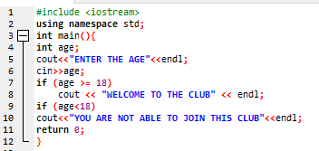

**Output:**

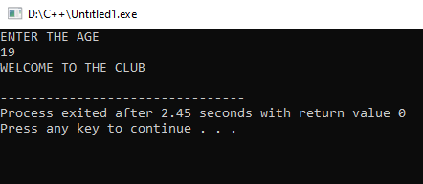

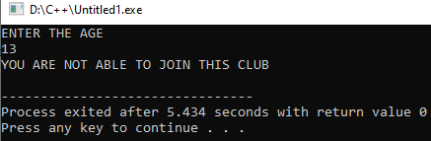

**If….else staement:**

The if statement lets you do something if a condition is true. If it is not true, nothings happens. But suppose we want to do one thing if a condition is true, and do something else if it’s false. That’s where the if…else statement comes in. It consists of an if statement, followed by a statement or block of statements, followed by the keyword else, followed by another statement or block of elements.

**Program :**

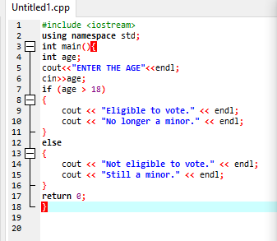

**Output :**

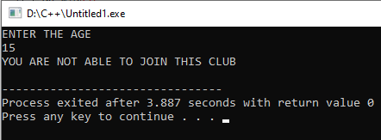

**If….else if statement:**

The nested if...else statements in the ADIFELSE program look clumsy and can be hard—for humans—to interpret, especially if they are nested more deeply than shown. However, there’s

another approach to writing the same statements.

**Program:**

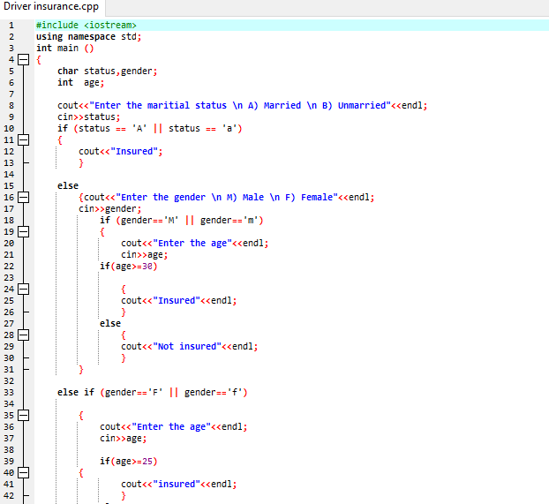

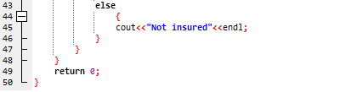

**Output:**

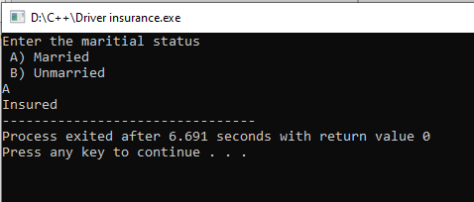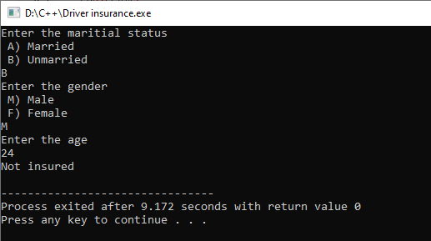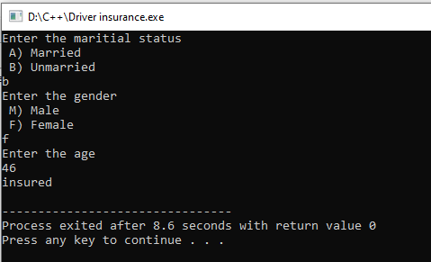

**Switch Statement:**

If you have a large decision tree, and all the decisions depend on the value of the same variable,

you will probably want to consider a switch statement instead of a ladder of if...else or else if constructions.

**Program:**

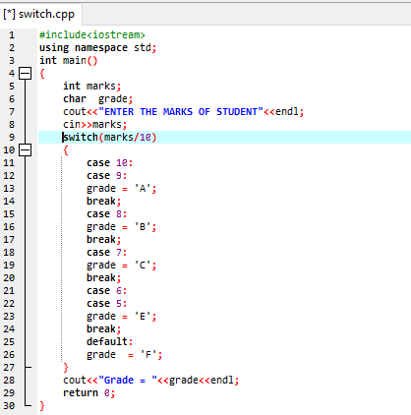

**Output:**

